ACTIVATE No. 35 March 2007
The Newsletter of the Association of CSPE Teachers (ACT)
Supporting Citizenship Education in Ireland
act@esatclear.ie www.cspeteachers.ie

Art Competition
We were delighted to receive a huge amount of impressive entries to our art/poster competition. In TY and junior sections students had to design posters that illustrated one or more of the seven basic concepts of CSPE, or the four units of study. The judging is now being finalised and a special award function is being planned, provisionally for Wed 25 April in Dublin – keep an eye on the news and calendar sections of the website (see above) for further information as it becomes available.

NALA Resources
The National Adult Literacy Agency provides resources that has some useful resources that should be of use to CSPE teachers and students as well as NALA’s primary audience. Check out www.nala.ie/publications and scroll to the bottom of the page to the section “Support Packs”. Particularly useful are The Plain English Guide to Citizenship Terms, The Plain English Guide to Political Terms, and Know Your EU. These can be downloaded free from the site. In addition the Know Your EU resource can be purchased in hard copy for €14.

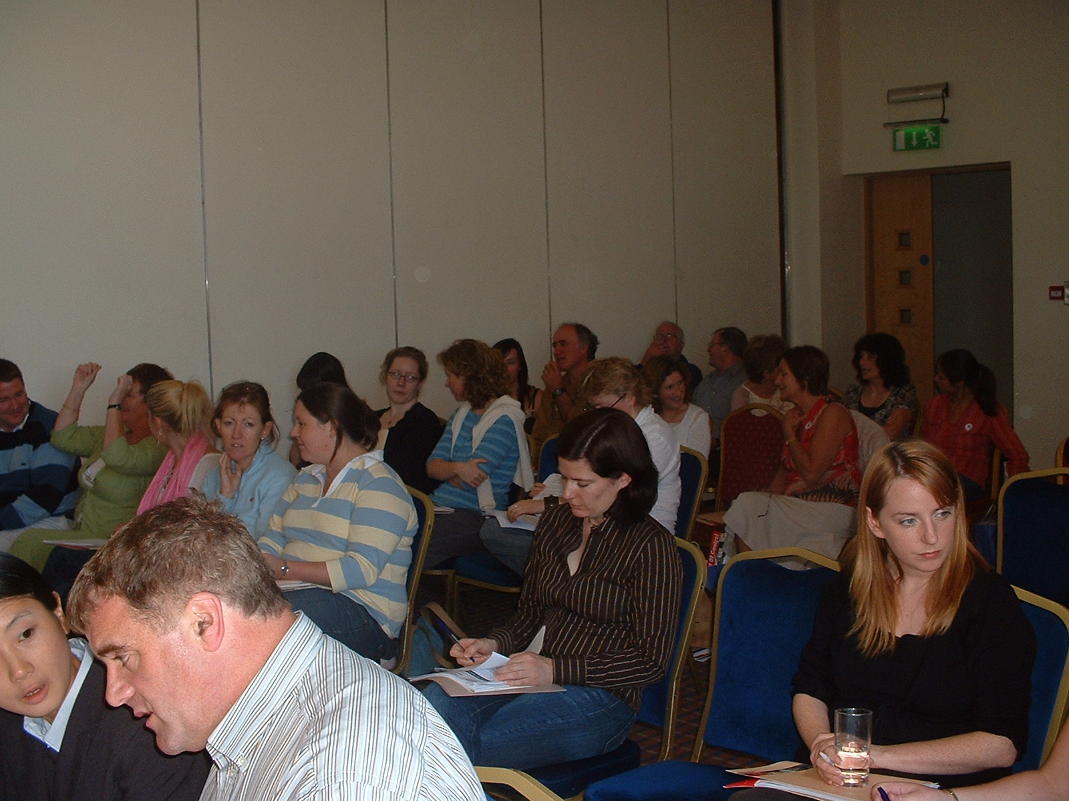
At the National Conference in The Arklow Bay Hotel Sept 2006

Dates and Deadlines
The official deadline for completion of RAPs and CWABs this year is Friday May 4th, though you might be advised to set an earlier and easy to remember in-school deadline, e.g. May 1st, to allow more time to chase up those who are slow to complete their RAPs or CWABs.

The CSPE Exam this year has changed to Friday morning of the first week. - 8th June 9.30 to 11.00 am. Perhaps this will mean students staying longer in the exam rather than extending the weekend by finishing extra early Friday afternoon!

This year the Support Service Helpline will be operational
Mon 23rd April 10.00 pm-5.00 pm and Fri 27 April 10.00 pm-5.00 pm. Conor Harrison: 01-610280

Membership Matters!
Your membership status is noted on the address label. To continue receiving Activate (one per term) please renew for 2006/2007 if you haven’t already done so. If you are not up to date you will get a reminder with this mailing. Also, if you are not on our email list and wish to join send an email to that effect using email address above.

Useful Revision Tools!

Some common and basic Irish language terms might be useful in the lead up to the written paper.

Áras an Uachtaráin | Where the President lives | Bunreacht na hÉireann | The Constitution of Ireland
An tOireachtas | The National Parliament | Dáil Éireann | House of Representatives (of Ireland)
Teachta Dála (T.D.) | Elected Representative | Seanad Éireann | Senate (of Ireland)
Seanadóir | Senator | Tithe an Oireachtais | Houses of Parliament
An Stát | The State | An Pharlaimint Náisiúnta | The National Parliament
An Rialtas | The Government | Ceann Comhairle | Speaker/Chair (of the Dáil)
Cathaoirleach | Chairman (of the Seanad) | An Chomh-Aireacht | The Cabinet
Aire | Minister | Freasúra | Opposition
Taoiseach | Prime Minister | Tánaiste | Deputy Prime Minister
Roinn | Gov. Department | An tAontas Eorpach | The European Union

Not to mention a list of current ministers:

Bertie Ahern TD | Taoiseach | Michael McDowell TD | Tánaiste, Justice, Equality & Law Reform
Mary Harney TD | Health & Children | Willie O'Dea TD | Defence
Mary Coughlan TD | Agriculture and Food | Brian Cowen TD | Finance
Dick Roche TD | Environment, Heritage and Local Government | Noel Dempsey TD | Communications, Marine and Natural Resources
Dermot Ahern TD | Foreign Affairs | John O'Donoghue TD | Arts, Sport and Tourism
Micheál Martin TD | Enterprise, Trade and Employment | Seamus Brennan TD | Social and Family Affairs
Martin Cullen TD | Transport | Eamon Ó Cuiv TD | Community, Rural and Gaeltacht Affairs
Mary Hanafin TD | Education & Science

And here are the 13 MEPs representing the Republic of Ireland:

Dublin (4):
Eoin Ryan, Fianna Fáil; Gay Mitchell, Fine Gael; Proinsias deRossa, Labour; Mary Lou McDonald, Sinn Féin

East (3):
Liam Aylward Fianna Fáil; Avril Doyle, Fine Gael; Mairead McGuinness, Fine Gael.

North-West (3):
Marian Harkin, Independent; Jim Higgins, Fine Gael; Seán Ó Neachtain, Fianna Fáil.

South (3):
Kathy Sinnott, Independent; Simon Coveney, Fine Gael; Brian Crowley, Fianna Fáil.

ADEI

Association for Drama in Education in Ireland

Using Drama in the teaching and learning of humanities at second level

Led by Céline Healy and Gerri Roche

ADEI is delighted to offer two interactive and practical workshops designed to meet the needs of second level teachers and arts practitioners who are keen to learn more about how to use educational drama techniques in their teaching. The workshops will be led by highly experienced and skilful teachers. Participants are invited to attend BOTH workshops OR either one, according to their level of interest in the subjects being explored on this occasion.

Workshop 1 (10.00am – 12.45pm): Drama and the teaching and learning of languages
This workshop will enable second level teachers of Modern Languages and Irish to practically explore how drama in education can be used to promote meaningful language use. Céline Healy is a language teacher with considerable experience at second level in Ireland and France. She is currently working at the School of Education and Life Long Learning at UCD and also at The School of Education, Trinity College Dublin.

Workshop 2 (1.15pm – 4.00pm): Drama and the teaching and learning of CSPE
As drama is recommended as a powerful, active learning methodology in the teaching of CSPE, this workshop will explore the topic of Refugees and reveal how its use can lead to greater understanding and empathy in students. Gerri Roche is a graduate of the University of London, and teaches Drama, English, CSPE and Art at Loreto Secondary School in Wexford.

Date: Saturday 21st April 2007
10.00am* - 4.00pm (coffee and registration from 9.30am)

Venue: Room 3074, Arts Building, Trinity College Dublin

Cost: €30 for Workshop 1 / €10 full time student or concession
€30 for Workshop 2 / €10 full time student or concession
€50 for Workshops 1 and 2

(*Please note: workshops will begin sharply on time)

------------------------------------------------------------------------------------------------------------
Please return this booking form to:

Ms. Emma Balfe, Room 3133, The Education Department, Arts Building, Trinity College, Dublin 2

Name: ________________________________________________________________________________________
Address:_____________________________________________________________________________________________________________________________________________________________________________________
Tel: _______________________ Email:________________________________________________________
Workshop 1 only:  Workshop 2 only:  Workshop 1 and 2: 
I enclose a cheque/postal order for Euro __________ (made payable to: ADEI).

The General Election As Action Project
by Brendan O’Regan, Arklow CBS

The coming General Election provides great opportunities for CSPE classes leading into the third term. Third years might be busy putting finisghing touches to their RAPs and CWABs, or preparing for the written paper, but following the election would make an ideal activity for second year classes. It could even be their main Action Project for Junior Cert. The preliminary work could be done leading up to the election, and the project could be completed in September with a study of the count results, assuming that the election is late May or June. There are various approaches for tracking an election, this article outlines one possible model.
Break class into small groups - one for each political party fielding candidates in the constituency, and one for independents if any. Each group must track their party's activities through the campaign, compiling written log/report, and making regular presentations/progress reports to class.
Resources will include local newspapers, election leaflets and posters, party and candidate websites.
Most candidates have been chosen at this stage, so a visit from each candidate would be ideal, though as the election approaches they may not have time, but may be willing to send a representative.
Party political broadcasts can be recorded from radio and TV (preferably by the student, though teacher might want to have a backup copy) and then played and discussed in class.
Opinion polls leading up to the election could be studied and compared to the national/constituency outcome. One student or team could be assigned to this work throughout the campaign.
Individual students or groups could be assigned to discover the location of polling booths in their area, and to compile a map or list for class, or they could interview a returning officer or election official. When the voting is over they might get to take away the official posters, especially the enlarged sample ballot papers, and bring them for display in class.
If time there could be a voter registration campaign, with junior CSPE students ensuring that pupils over 18 can vote, and/or having students encouraging parents/guardians to register and vote.
A mock or mirror election could be held, either with imaginary candidates or having the students voting on the actual candidates. The school/class result could be compared with the constituency outcome.
The relevant sections of the Constitution on election procedures and requirements could be studied (have a class set in the school!). The count could be used to examine the PR voting system.
Each group should make their final report to class on how their candidate(s)/party did. It might be possible to bring/send a group of students to the local count centre.
Allow for a review and reflection class, which will feed in to the relevant section of the RAP or CWAB.
Activate is published once per school term by the Association of CSPE Teachers—supporting citizenship education in Ireland. Articles and letters for publication should be sent to the editor, Brendan O’Regan, Arklow CBS, Co. Wicklow, 0402-39176, or emailed to act@esatclear.ie

