ACTIVATE No. 36 May 2007
The Newsletter of the Association of CSPE Teachers (ACT)
Supporting Citizenship Education in Ireland
info@cspeteachers.ie www.cspeteachers.ie

CSPE Exam!
This year’s CSPE Exam is on Friday 8th June 9.30-11pm. Following this, at 12 midday we will have our annual exam review in The Blackrock Education Centre, Kill Avenue. Our observations will be released to the media and passed on to the Dept inspectors and State Examinations Commission. All members are welcome and urged to attend.

New Text
A new edition of the CSPE Textbook Make A Difference! is now available. It is written by Conor Harrison and Mairin Wilson and published by Folens. It comes with a workbook and teacher's manual.

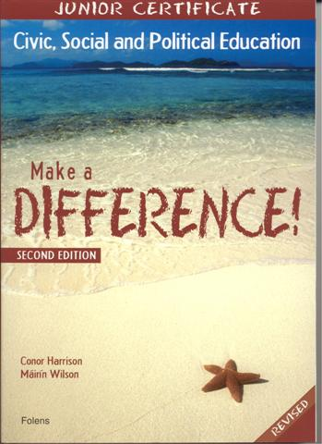
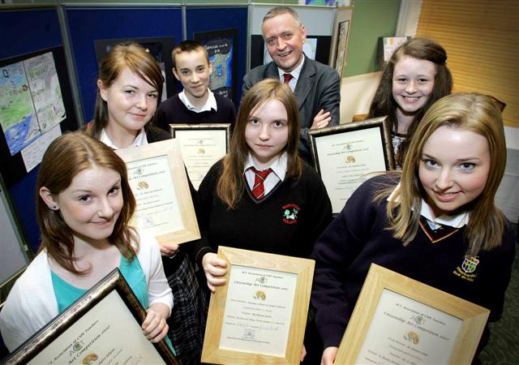
Prizewinners in our poster/slogan competition competition, with Frank McDonald of The Irish Times who presented the prizes. Picture by Colin O'Riordan, Evening Herald.

Slogan/Poster Awards
Our Slogan/Poster competition was a great success with over 2,000 entries. Prizes were presented at a ceremony in Mercer's Hotel Dublin on Wednesday 25th May. The awards were presented by Frank McDonald, Environment Editor of The Irish Times. Congratulations to all our prizewinners:
Transition year 1st Prize - Ms Shauna Kane St Mary's Secondary School Ballina, Co Mayo, Teacher : Mr C Allen
2nd Prize Mairead Shannon Hazelwood College Dromcollogher Co Limerick teacher ; Ms Maria Curtin
3rd Prize Ms Dorothy Szebenie, Hazelwood College, Dromcollogher Co Limerick, teacher Ms Maria Curtin
Junior Certificate 1st Prize Shannon Quilty, St Augustine's College Teacher : Mr P MacCraith Duckspool Abbeyside Co Waterford
2nd Prize Shane O'Riordan, Ballbriggan Community College. Teacher: G. Murphy
3rd Prize Claire Glynn, Glenamaddy Community School, Co Galway. Teacher Ms Lisa Conboy
Membership Matters!
Your membership status is noted on the address label. If you are not on our email list and wish to join send an email to that effect using email address above.

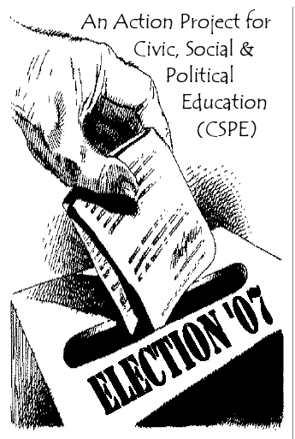
Election ‘07

In the last edition of Activate we encouraged teachers to consider doing an Action Project on the General Election, and outlined some strategies for approaching this. It’s not the best timing, but 1st yrs and 2nd yrs would benefit – either as a dry run project or as the final Action Project for 2nd yrs, the voting patterns to be dealt with in September.
The CSPE Support Service has now produced a new 20-page Resource, Election ’07, that includes lots of activites relating to the election. It is available as a free download (http://cspe.slss.ie). There are sample ballot papers in colour, plans for a Mock Election Action Project, a very useful candidate profile sheet, a party profile sheet, work on the party logos, This resource This General Election ‘07 Action Project resource has been adapted by the Citizenship Education Support Team of the Second Level Support Service from

VOTE: Exploring Democracy, Equality, Participation and Elections
written by Deirdre Phelan, 2005
and published by The Gender Equality Unit of the Department of Education and Science and The CDVEC Curriculum Development Unit.

-----------------------------------------------------------------------------------------------------------------------

Young Environmentalists
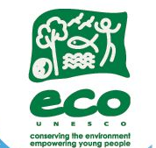
ECO-UNESCO is holding its Young Environmentalist Awards Showcase 2007 in the Round Room of The Mansion House, Dawson Street, Dublin 2 on 21st May which will be officially launched by the Lord Mayor of Dublin, Councillor Vincent Jackson at 11.30am. The showcase will be followed by the Young Environmentalist Awards Ceremony from 3.30 to 6.00, which is open to invited guests only and mc'd by Aidan Power of 2TV.
The Showcase will be open from 11.30 - 2.30 to all and will include :
- an exhibition of 34 Young Environmentalist projects and a chance to talk to the Young Environmentalists!
- a Bio-Zone - an interactive BioDiversity exhibition made up of biodiversity sensory boxes, trips, biodiversity games and activities. The BioZone is part of ECO-UNESCO's activities for Biodiversity Week.
- an opportunity to learn about your ECO-Footprint and to find out how you can lessen it.
- More fun games and activities.
Leaders and teachers interested in bringing their groups to the YEA Showcase 2007, should contact Joanne Pender, ECO-UNESCO Young Environmentalist Awards Coordinator, before Thursday 17th May at:
ECO-UNESCO, 26 Clare St., Dublin 2, Ireland, Ph: 00353 1 6625491 / Fax: 00353 1 6625493
Email: yea@ecounesco.ie / Web: www.ecounesco.ie

May and Summer Activities with Eco-Unesco

Here comes the sun…and ECO-UNESCO’s Summer Programme 2007!
ECO-UNESCO, Ireland’s environmental education and youth organisation will run its Summer Programme 2007 in Phoenix Park, Dublin 8. This year, the programme will include activities aimed not only at young people but also at leaders and teachers or anyone interested in working with young people.
Young people will have the opportunity to take part in a fun woodland treasure hike based on Lord of the Rings and its characters. While exploring Irish woodlands in an interactive and exciting way, there will be also space for team building exercises and sensory development.
The training programme for leaders and teachers will offer two different one-day training courses: ‘Energy Watchers’ and ‘Waste Watchers’. Both courses provide participants with the knowledge and skills to successfully work on environmental issues and to carry out an environmental action project with young people using active learning and varying methodologies.
If you are interested in having more information or book a place at ECO-UNESCO’s Summer Programme 2007, please contact us at:
ECO-UNESCO, 26 Clare St., Dublin 2, Ireland
Ph: 00353 1 6625491 / Fax: 00353 1 6625493
Senan Gardiner (Youth Programme) - youth@ecounesco.ie
Melissa Bendall or Sorcha O’Brien (Training Programme) - training@ecounesco.ie

ECO-UNESCO’s Biodiversity Week – Youth for Biodiversity!

May 21st – 27th is Biodiversity Week, where all around the world people will be “getting back to nature” and seeing the amazing biodiversity of Ireland and the world.
Bio-Zone
This year at the Young Environmentalist Awards Showcase and Ceremony we will have an exciting Bio-Zone. The Bio-Zone is an interactive biodiversity exhibition with sensory boxes, exciting quizzes, trips and much more! Come along and explore!
Time: Mon 21st May 11.30-2.30
Venue: Round Room, Mansion House
Age:12-18
Admission: Free!!

Explore, Design and Act Wild for Biodiversity Week
Have you ever wondered what biodiversity is? Or what type of wildlife we have in our cities and in our woodlands? Or what you can do to help nature in Ireland and the world? If you want to find out then come along to these two very exciting free full-day ECO-UNESCO events for Biodiversity Week.

These events are open to all 12 –18 year olds and it’s all FREE. All you need to do is call Senan Gardiner at ECO-UNESCO and book your place. You can come for one day or for both days but you need to let us know.

Day 1: Design Your World!
When it comes to the environment it’s good to “walk the talk” and “wear your heart on your sleeve”… Come with us as we get you exploring the wilderness of urban wildlife in an exciting urban safari and then design a t-shirt to spread the word on why we need to protect wildlife!
Time: Fri 25th May 10-3pm
Venue: Meeting at ENFO 17 St. Andrew Street at 10 am
Age:12-16: T-shirts and lunches will be provided on the day
Admission: Free!! Places limited! Please book in advance using the number below

Day 2: Act Wild!
Act wild for the environment for the sake of wildlife. On this day we’ll be going out to the wooded wilds of the Wicklow Mountains where we’ll take a woodland trail to explore our woodland biodiversity. Next we’ll use drama techniques and role-playing to explore our global impact on wildlife and come up with solutions that suits everyone
Time: Sat 26th May 10-3pm.
Venue: Knocksink Woods
Age: 10-15
Admission: Free!! Places limited! Please book in advance using the number below

If you are interested in participating in the event above please contact Senan Gardiner, ECO-UNESCO’s Environmental Youth Officer on +353 1 662 5491 or email us at youth@ecounesco.ie

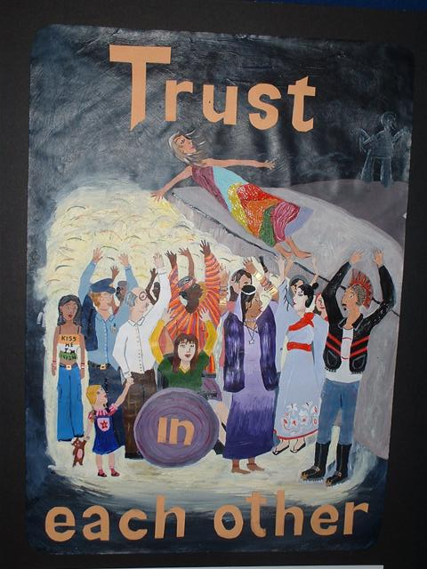  1st Prize Junior Section  Shannon Quilty, St Augustine's College | 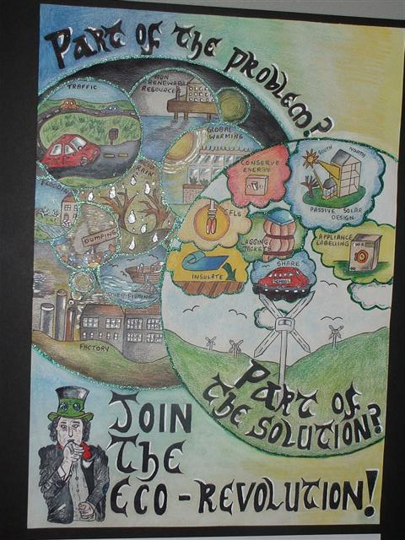  1st Prize Transition Year Section  Ms Shauna Kane St Mary's Secondary School Ballina, Co Mayo,
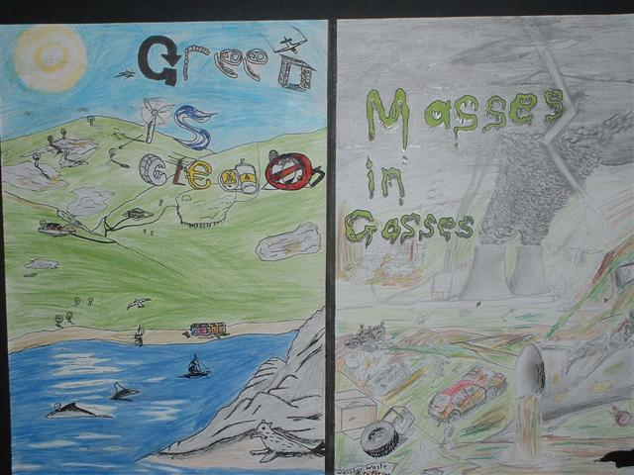  2nd Prize Junior Section  Shane O'Riordan, Ballbriggan Community College. | 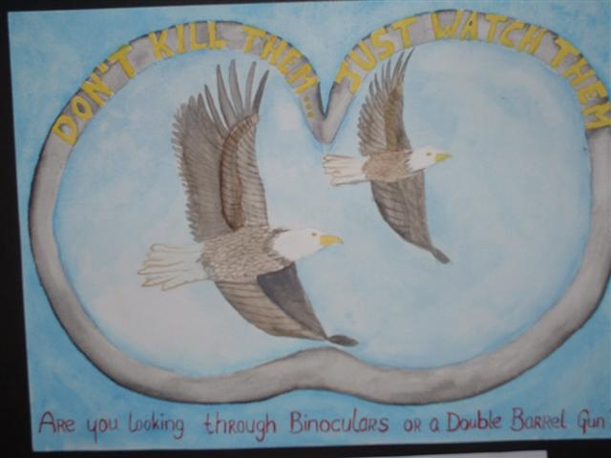  2nd Prize Transition Year Section  Mairead Shannon Hazelwood College Dromcollogher Co Limerick,
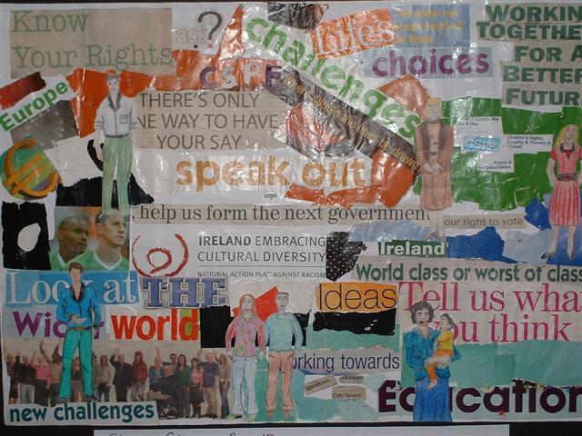  3rd Prize Junior Section  Claire Glynn, Glenamaddy Community School, Co Galway. | 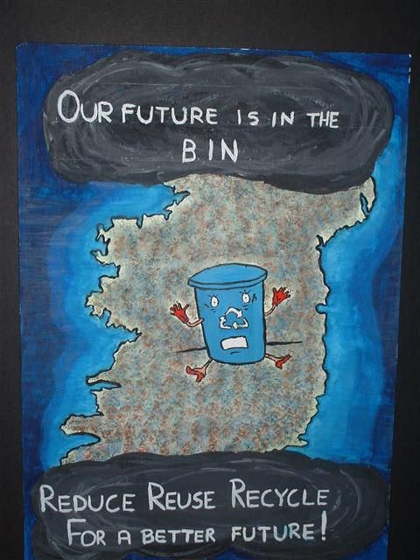  3rd Prize Transition Year Section  Ms Dorothy Szebenie, Lynda O’Sullivan, Hazelwood College, Dromcollogher Co Limerick,
Activate is published once per school term by the Association of CSPE Teachers—supporting citizenship education in Ireland. Articles and letters for publication should be sent to the editor, Brendan O’Regan, Arklow CBS, Co. Wicklow, 0402-39176, or emailed to info@cspeteachers.ie

