ACTIVATE No. 37 Oct 2007
The Newsletter of the Association of CSPE Teachers (ACT)
Supporting Citizenship Education in Ireland
info@cspeteachers.ie www.cspeteachers.ie

Art Competition
This year, at the Annual Conference, we are launching our 2nd annual Poster/Slogan competition. Last year’s competition was a huge success, attracting over 2000 entries. Brochures have been sent to schools, and are also included with this mailing. Deadline for entries is December 1st and there will be a prize giving event in the Spring.

New Resource
80: 20 - Development in an Unequal World - 5th edition - is an updated
version of a popular resource dealing with the inequalities in the
world. It is described as a comprehensive introduction to development,
justice and human rights issues. It is available from 80:20 Educating
& Acting for a Better World, St. Cronans BNS, Vevay Road, Bray, Co.
Wicklow. ph: 01-2860487. Cost is 25 Euro + Post and Packing.
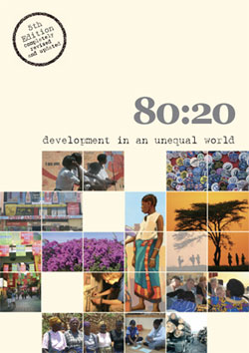
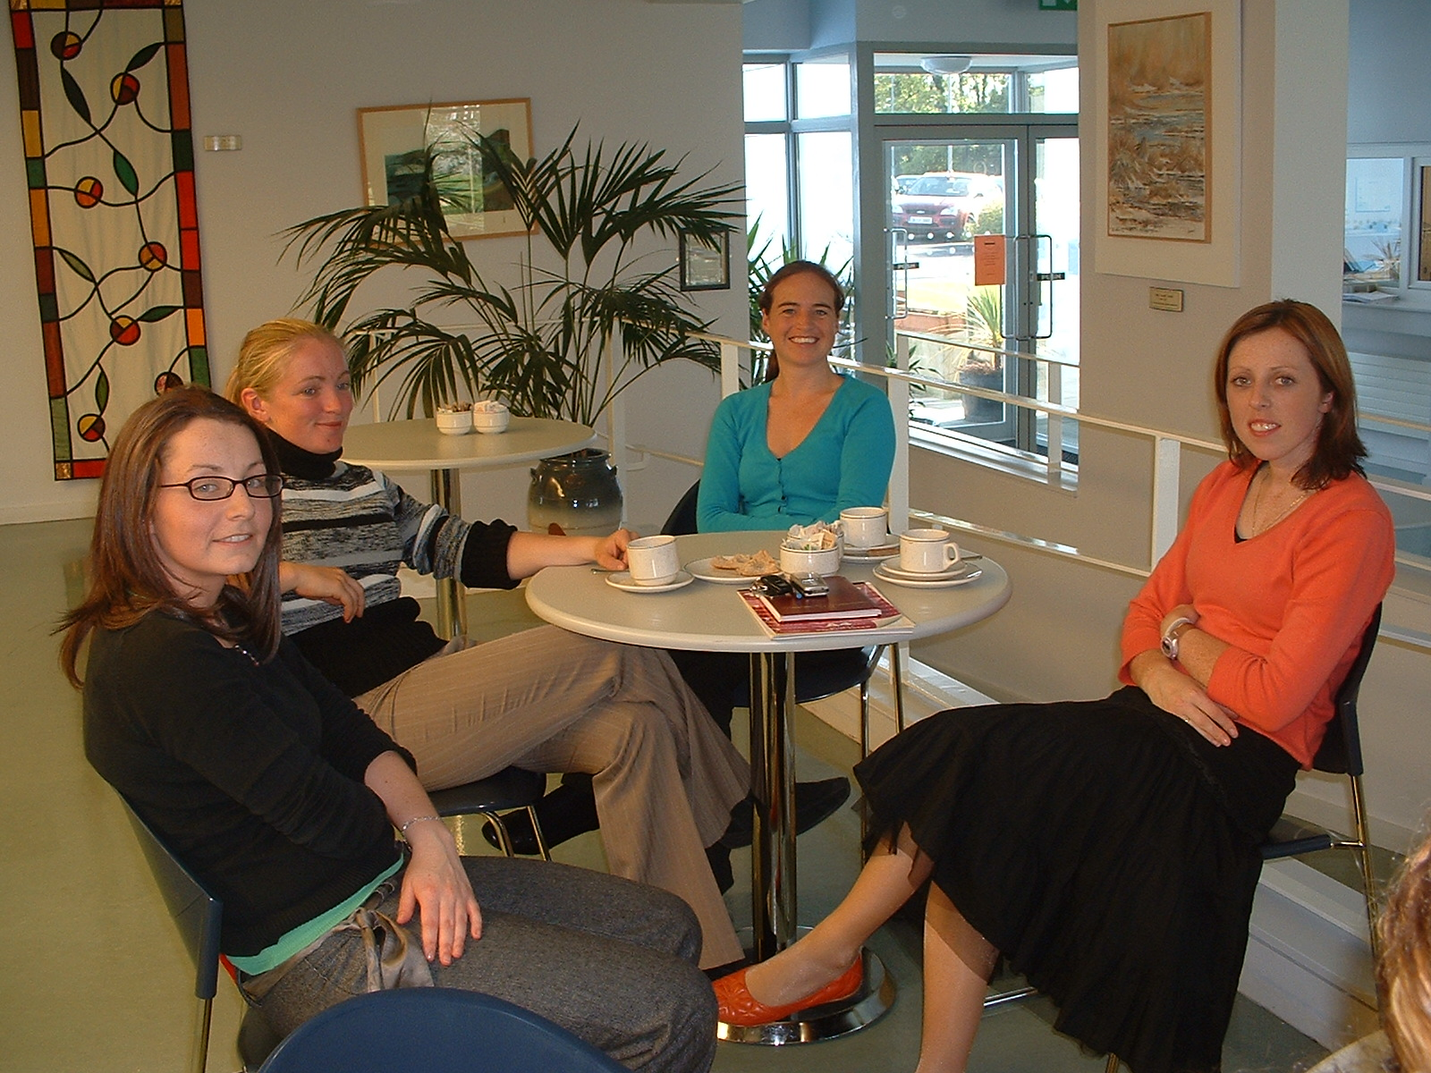
Teachers at our CSPE Workshop in Co. Wexford Education Centre, Enniscorthy,
On Tuesday 25th September.

Conference 2007!
This year’s conference will take place on Saturday 20th October, in the Plaza Hotel, Tallaght, Dublin (beside The Square Shopping Centre and near Luas station and M50). This year’s theme is “Denial of Citizenship” – keynote speaker (at 10.00 am) is Holocaust survivor Tomi Reichental, whose story is impressive and moving, and there is also a follow-on workshop on the Holocaust and CSPE. Other workshops include Teaching the Constitution (when we hope to launch a new resource) and Conflict Resolution With Young People, along with our usual crucial workshops on Managing Action Projects and Reporting on Action Projects. Booking forms have been sent to schools, and are also included in this mailing. Deadline for applying is Tuesday Oct 9th – see forms for relevant addresses.
Membership Matters!
All memberships for 2007/2008 are due now. Please send €20 to our Treasurer Bernadine O’Sullivan,
131 Fortfield Rd, Terenure, Dublin 6W.

Inservice Programme

The official inservice programme from the CSPE Support Service continues through October and November. Details and booking forms have been sent to schools.

Induction course for teachers new to CSPE:

Monday | 8th October | Cork Education Support Centre
Monday | 8th October | Monaghan Education Centre
Tuesday | 9th October | Dublin West Education Centre, Tallaght
Monday | 15th October | Cork Education Support Centre
Monday | 22nd October | Athlone Education Centre
Monday | 22nd October | Carrick-on-Shannon Education Centre
Tuesday | 23rd October | Kilkenny Education Centre
Thursday | 25th October | Mayo Education Centre, Castlebar

Organising and Managing Action Projects:

Tuesday | 13th November | Navan Education Centre
Tuesday | 20th November | Curriculum Development Unit, Crumlin
Thursday | 22nd November | Limerick Education Centre
Monday | 26th November | Laois Education Centre, Portlaoise
Tuesday | 27th November | Waterford Teachers’ Centre
Thursday | 29th November | Sligo Education Centre

OSSP sna scoileanna Ghaeltacht agus sna Ghaelscoileanna:

Déardaoin/Dé hAoine | 18/19 Deireadh Fómhair 2007 | Ostán Chósta Chonnemara, Na Forbacha, Contae na Gaillimhe

School-based in-service:

The members of the Citizenship Education Support Team are available to facilitate school-based in-service for teachers of CSPE on request, on a first come, first served basis.

Local Network Meetings:
A number of evening meetings/workshops on Civic, Social and Political Education will be facilitated during the Autumn term in collaboration with Education Centres. Details of meetings/workshops will be made available through your local education centre nearer the time.

Support for Student Councils:
From the 1st of September Ms. Deirdre Phelan will be joining the Citizenship Education Support Team as Assistant National Co-ordinator with responsibility for supporting schools in establishing and developing Student Councils. A programme of support regarding student councils will issue directly to schools in September/October.

Junior Certificate CSPE Paper June 2007

– Response from Association of CSPE Teachers

This year we gave the paper a broad welcome, with a positive response from the members who met in Blackrock Education Centre on Friday 8th June to discuss the paper.

It was a colourful paper, with a good quality colour insert. This year for the first time colour pictures were added to the questions in Section 3. While the pictures were not central or necessary to the questions asked they may have been a useful prompt for some students.

We welcomed the topicality of many issues, including the general election/mock election question, and the question on global warning. We especially were glad to see that the Darfur genocide was not forgotten.

In Section 3 Question 1 we felt that the idea of community should have been mentioned as it is an important idea in CSPE, one of the four units of study in the syllabus. Question 1 (a) could have been more focussed in relation to the three pieces of key information required for those attending the Know Your Neighbour event.

Overall the paper was manageable for weaker students, but also allowed the more able student to do well.
-----------------------------------------------------------------------------------------------------------------------

ECO-UNESCO Young Environmentalist Awards 2008

The Young Environmentalist Awards (YEA) is run by ECO-UNESCO - Ireland’s environmental education and youth organisation. The YEA is an all island environmental awards programme for young people between the ages of 12 and 18. The awards honour young people who protect, conserve and enhance our environment, making a difference in the lives of others locally and globally, by carrying out projects on environmental issues.
ECO-UNESCO are offering half day training to teachers interested in carrying out a YEA project with their students. Remaining date (Limited Spaces Available):

13th Oct ‘07 | 11am – 1pm | Westside Library, Seamus Quirke Road, Galway, Co. Galway.

Register Now! Register now to avail of YEA Training in September and October 2007.
The registration deadline is 30th Nov 2007.
You can register online at www.ecounesco.ie or contact ECO-UNESCO. When you register you are entitled to a YEA Manual to help carry out your project.

Closing Date for completed projects: 2nd March 2008. (no entries will be accepted after this date)
Submit your completed project reports and supplementary materials before this date.

Showcasing and Awards Ceremony: May 2008
Short-listed projects will be showcased and achievements celebrated at a fun day for all.

The YEA Project Themes:
Biodiversity, Energy, Water, Waste, Transport, Consumerism, Climate Change, Eco-Community Development, Eco-Art & Design, Eco-Enterprise, Eco- Technology, Cross Thematic, Other.
(please note these themes are only guidelines, please feel free to submit your own ideas)

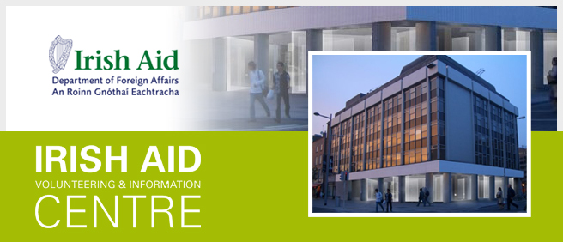

Irish Aid will open a new Volunteering and Information Centre on O'Connell St, Dublin in November 2007.
The Irish Aid Volunteering and Information Centre is a state of the art, flexible multi-media exhibition space designed to raise awareness of development issues and the role of Irish Aid in tackling global poverty. It offers a dynamic environment for individuals and groups to learn about and engage with the work of Irish Aid and will provide information on development-related volunteering opportunities. It will feature a range of interactive displays, an exhibition area, a workshop area for approximately 30 people and a conference area with capacity to host 100 people.
Schools and Groups
School and youth groups are encouraged to visit the Irish Aid Centre to learn more about development and the international and Irish response to global development challenges.
It is envisaged that the programme for school groups will take place at 10am and 2pm on weekdays from December 2007. The Programme takes about 1½ hours.
The groups visit includes 45 minutes in the multi-media exhibition area to learn about the millennium development goals and the work of Irish Aid. The second stage of the visit includes a 45-minute workshop where the groups will be involved in hands-on activities to deepen understanding of how Irish Aid works, and stimulate discussion on development issues such as health, human rights, environment and child labour.
There are pre-visit materials available for teachers and youth workers, but preparation is not essential for the workshops.
Activate is published once per school term by the Association of CSPE Teachers—supporting citizenship education in Ireland. Articles and letters for publication should be sent to the editor, Brendan O’Regan, Arklow CBS, Co. Wicklow, 0402-39176, or emailed to info@cspeteachers.ie

