ACTIVATE No. 38 March 2008
The Newsletter of the Association of CSPE Teachers (ACT)
Supporting Citizenship Education in Ireland
info@cspeteachers.ie www.cspeteachers.ie

Poster/Slogan Competition
Once again there has been a huge entry for our poster/slogan competition. There will be an awards ceremony on April 23rd and details will be posted on our website and sent on the email list as soon as arrangements are finalised.

New Resources
The President of Ireland: Role and Functions
This is a new DVD (2008) the title of which explains it all. It is an educational resource produced by the Office of the President with advice from the Department of Education and Science. It is bilingual and comes with a CD-Rom of teachers' notes.
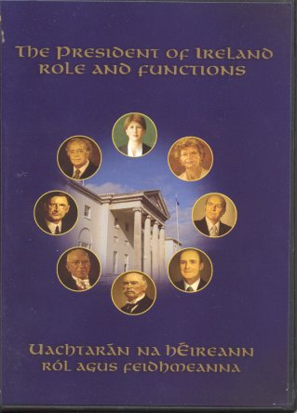

Look out also for another new DVD/Pack on the way soon: Lets Look at the Law is produced by the Courts Service. It should be arriving in schools soon.
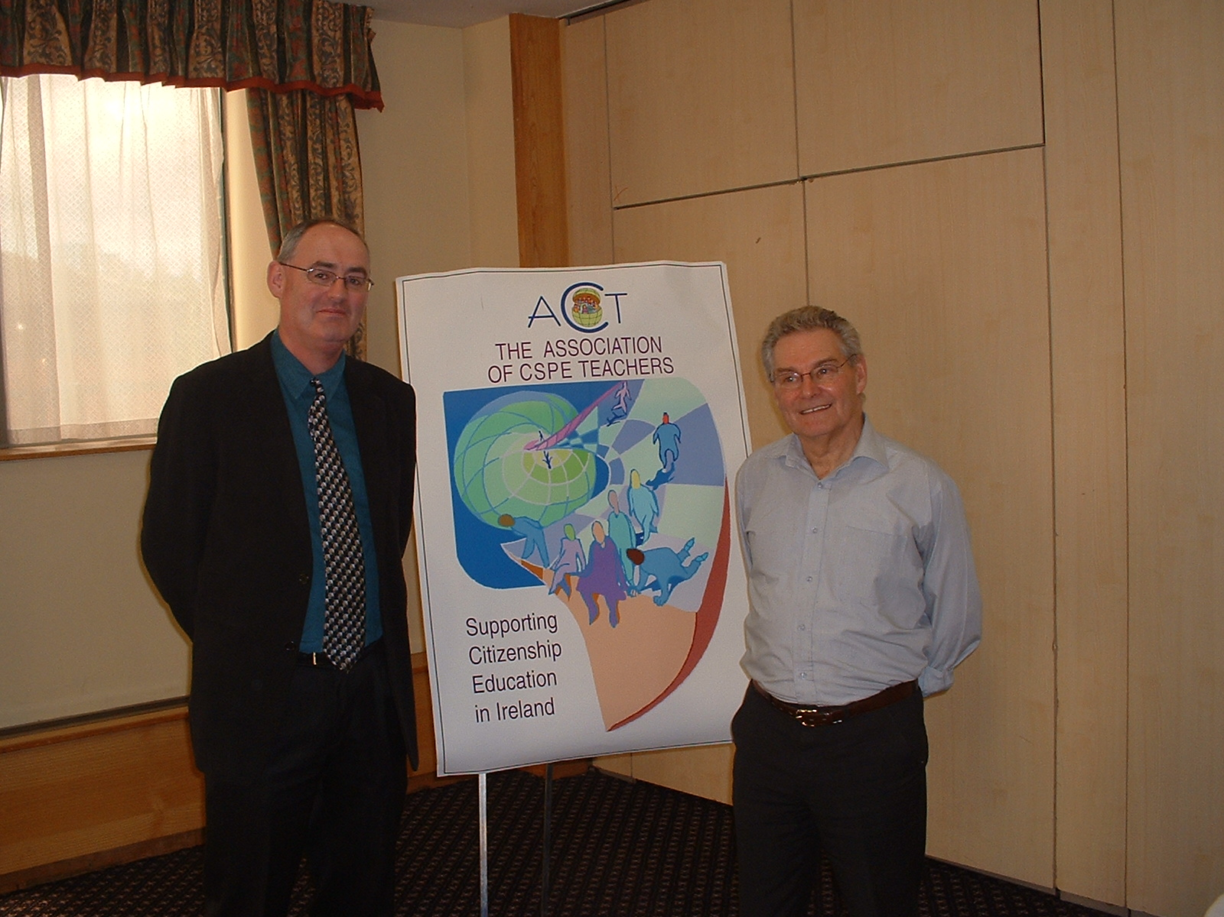
Our Chairperson Phillip Irwin with Holocaust Survivor Tomi Reichental at our Conference and AGM in October.

Important Dates
This year’s deadline for submission of Action Project Reports and Course Work Assessment Books is May 2nd. The pro-forma booklets have already been sent to schools, and will be followed after Easter by the distinctive blue bags into which they will be sealed. The Support Service will have a helpline available on the following dates: Mon 21st and Fri 25th April, 10 am to 5 pm. Conor Harrison – 087-2405710, Eileen Gray 087-6485649, Eileen Coleman 087-2405713. This year’s CSPE Exam will take place on Mon 9th June 1.30 pm to 3.00 pm, after which we will will have our annual review of the paper (details in next issue). This year’s Europe Day is on May 9th as usual, and we would like to hear from any teachers who mark this in an interesting way in school. More information is available at this site:
http://ec.europa.eu/europeaid/9-may-initiative/index_en.htm

Membership Matters!
Memberships for 2007/2008 are overdue. Please send €20 to our Treasurer Bernadine O’Sullivan,
131 Fortfield Rd, Terenure, Dublin 6W.

Lisbon Treaty Vote
The referendum on the Lisbon Treaty is due in May or June. We’d love to hear from any teacher brave enough to tackle it as an Action Project! Timing wise it would be ideal for second year students, but it seems to be too complicated for many adults, never mind our students. Nearer the time there will be useful information on the Referendum Commission website (www.refcom.ie) , which at the moment still has plenty of useful information on past referenda. It seems that the Children’s Rights Referendum has been postponed until next school year.
Global Week of Action
Letters have been sent to School Stewards drawing attention to the 2008 Global Week of Action (in April), in relation to child labour and education. It is supported by the teacher unions, and a resource pack is available for CSPE teachers. Further info is available at www.campaignforeducation.ie
In.Tuition
The Irish Independent has circulated schools with an offer on the remaining issues of In.Tuition, their CSPE supplement. The nine issues are available for €4.50 per student, and there's a giant CSPE wall chart with every order. For more info call 023-63850.
Support Service Forum
One of the features of the official support service website (http://cspe.slss.ie) is a discussion forum (see link on left of home page), but it is hopelessly underused. It could be a most useful vehicle for communication between CSPE teachers, e.g. swapping advice on best texts and other resources.
Active Citizenship
The website of the government initiative Taskforce on Active Citizenship does not seem to be very active, but there are some useful resources – you can for example download a copy of the booklet The Concept of Active Citizenship, ideal bedtime reading for CSPE teachers.
-----------------------------------------------------------------------------------------------------------------------

New Citizenship Education Initiative for Dublin

Dublin City Public Libraries will be piloting a citizenship and voter education programme this Autumn and is interested in consulting with CSPE teachers in the planning stage and in including CSPE classes in the delivery of activities such as:
- Forum discussions on a specific theme with elected representatives,
- Voter education workshops
- Know Your City Council with invited guest speakers such as a senior local government official.
DCPL is currently researching and will publish a Know Your City Council resource of interest to those interested in the democratic process.

If you are interested in participating in this programme (would be interested in hearing from schools in the Dublin City Area ) contact:
Bernadette Cogan
Research and Projects
Dublin City Public Libraries
Tel: 01 6744876 or email: bernadette.cogan@dublincity.ie before April 11th.
NEW LEADERS!

This has been quite a year for new political leaders! We wouldn’t be surprised if a few of them turned up on this year’s CSPE paper.

  John Gormley, Green Party |   Nicholas Sarkozy,  French President | 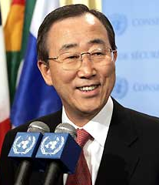  Ban Ki-Moon  UN Secretary General
  Gordon Brown  British Prime Minister |   Eamonn Gilmore,  Labour Party | 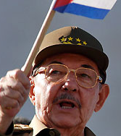  Raul Castro  President of Cuba

.
CSPE Resources at Teachnet.ie!
– Resources by teachers for teachers and students

Stewardship & CSPE - Author: Fiona Williams
This site addresses the theme of stewardship within the syllabus for CSPE. The following five aspects of the theme are explored are explored in detail: recycling; climate change; pollution; biodiversity; energy.

Irish Politics - Polatíocht na hÉireann - Author: Karen Varley
The web site is intended to accompany and reinforce normal classroom teaching. It uses several approaches in order to keep the students interest.

Human Rights, Europe, Environment, Government - Author: Michael Morgan
Through the use of interactive exercises the website reinforces many of the theoretical elements on the CSPE. Word Searches, Mouse overs, Quizzes, Games, Crosswords, Drag and Drop exercises are just some of the features.

New CSPE Resource on Data Protection and Privacy!
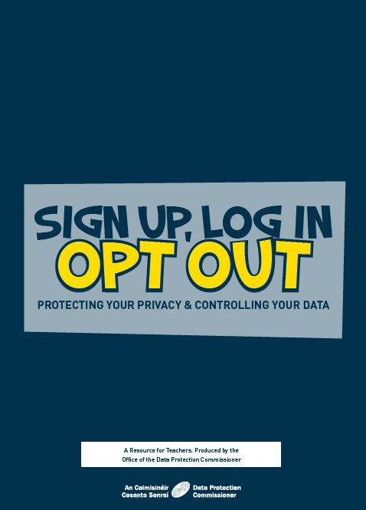
The Office of the Data Protection Commissioner, in conjunction with the Curriculum Development Unit of the Dept of Education and Science, has developed a resource for the CSPE (Civic, Social and Political Education) programme for Junior Certificate Students. The resource is called 'Sign Up, Log In, Opt Out: Protecting your Privacy & Controlling your Data' and deals with 2 of the core concepts of CSPE; 'Rights & Responsibilities' and 'Law'.

The resource will raise awareness amongst young people of their rights to privacy, the importance of taking control of their personal information, the rights they have when it comes to how their personal information may be collected or used and also how they may access their personal information. The resource is currently being distributed to all secondary schools nationwide and is also available to download from www.dataprotection.ie/teens

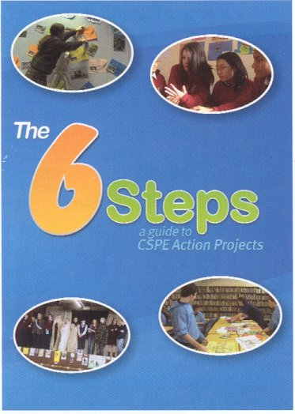
The 6 Steps – A Guide to Action Projects
At the Autumn Inservice the Citizenship Education Support Team launched The 6 Steps – A Guide to Action Projects, a new DVD on Action Projects for CSPE, which no doubt will be welcomed by all CSPE teachers.
The CSPE Action Project is broken into six steps which are followed in the DVD.
For more information contact National Co-ordinator Conor Harrison (01-6102805) or the Citizenship Education Administrator Vicky Geraghty (01-4020422).
The DVD has been given out at inservice and will also be sent to schools shortly.

Activate is published once per school term by the Association of CSPE Teachers—supporting citizenship education in Ireland. Articles and letters for publication should be sent to the editor, Brendan O’Regan, Arklow CBS, Co. Wicklow, 0402-39176, or emailed to info@cspeteachers.ie

