ACTIVATE No. 40 Dec 2008
The Newsletter of the Association of CSPE Teachers (ACT)
Supporting Citizenship Education in Ireland
info@cspeteachers.ie www.cspeteachers.ie

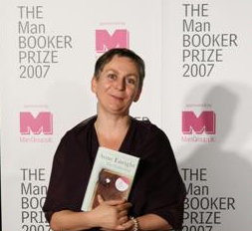
Celebrating the Universal Declaration of Human Rights
This is a new CSPE Resource pack from Amnesty International and CDU. It features a variety of activities and a CD Rom with backup resources for the teacher. Copies were sent to schools in September and the resource can be downloaded at http://www.amnesty.ie/live/irish/article.asp?id=23397&page=00
Images and Objects: Active Methodology Toolkit
This is a new resource on sustainable development from the Consumer Citizenship Network. A selection of images is included with guidelines on their use. (This resource can be downloaded at http://cspe.slss.ie/resources/ESD%20Toolkit%2Epdf

Annual Conference
Our Annual Conference had to be delayed this year, as there was uncertainty about funding in the current economic climate. It will now take place on Sat 7th February 2009 in the Blackrock Education Centre, Kill Avenue, Blackrock Co. Dublin. As it has been past practice that the AGM takes place immediately after the Conference this too will take place on the same day. Check out the News page of our website (cspeteachers.ie) for the latest information. Brochures will be in schools in early January.
The good news is that our keynote speaker will be Man Booker Prizewinner Anne Enright (above), who will talk about her recent human rights work. The Conference will celebrate 60 Years of the Universal Declaration of Human Rights, and will include workshops on a new Amnesty Resource on the Declaration (see over). Other workshops planned include the Know Your Council resource (see page 4), subject inspection in CSPE, and of course managing and reporting on Action Projects.

Bóthar
In recent days Bóthar has sent a DVD about its development work to all schools - with separate copies for the Head of CSPE, Head of RE, TY etc so there should be a few copies around.

Membership Matters
Memberships for 2008/2009 are now due. Please send €20 to Bernadine O’Sullivan, 131 Fortfield RD, Terenure, Dublin 6W. Check mailing label for status.
Poverty Week
One school has taken on an unusual project - Poverty Week It's at
http://povertyweek.webs.com/index.htm, where you can read blogs of students doing a week of simulated poverty to raise awareness of the issue.
Powerpoint Downloads
As the mock exams approach we can offer updated versions of our Powerpoint downloads that might be of use: Famous Faces Powerpoint - presentation including many of the new political leaders of recent times; Famous Political Buildings - based on pictures that came up in the exam paper a few years ago; CSPE Facts - revision aid with some useful facts and figures for Section 1 of the exam paper; New Government Ministers – the current Cabinet (we also have a Word document with colour pictures of the cabinet). We can send these on request – email act@esatclear.ie or info@cspeteachers.ie
Oireachtas Resource
Look out for a letter recently sent to principals about outreach education on the Houses of the Oireachtas. There's an education programme aimed at CSPE students which is available from November 2008 to secondary schools. From the letter: "Our programme is aimed at second and third year students and will involve a half-day session given by Ouireachtas Outreach Officers (based in 13 regions throughout the country) ... you can expect to be contacted by an Outreach Officer to arrange a suitable date and time for a preparatory school visit ... If you require further information ... contact communications@oireachtas.ie or phone 01-6183066 or 01-6183166".
ACT Response to CSPE Paper June 2008
“We give the paper a broad welcome - it covers a fairly broad spectrum of issues - e.g. national politics and other political information in the short questions in Section 1, in Section 2 subjects like Fair Trade, Ombudsman for Children, Self Help, Bin it Chewing gum/litter/Environment campaign, and in Section 3 the topical Martin Luther King Anniversary (human rights), also topical Year of Planet Earth including Climate Change, International Women's Day, Motorway Development, (a better visual prompt would have helped here - e.g. a motorway going through countryside.
The paper was strong on environmental issues, but weak on political issues. The concept of democracy was not well covered, and there was almost nothing on law. Apart from one very short multiple-choice question, European/EU matters were strangely absent considering the Lisbon Treaty referendum this year. It would have been more topical also if there had been more on the referendum process, and the voting process.
In the chewing gum/litter question Section 2 Question 3 a certain gum manufacturer gets a plug as the responsible chewing gum company - product placement? The question Section 2 Question 2 on the Ombudsman for Children was a positive question, part (d) was particularly good - asking what actions schools could take to hear the opinions of children. Section 2 Question 3 has the instruction "you must not use any of the actions you have mentioned already" - this was ambiguous as to whether it applied to this question, or the whole paper.
The question on Eritrea, Section 2 Question 4 would have been more topical if Darfur had been in question instead. Section 3 Question 4 was a challenging question, with two concepts linked, climate change and the difficult concept of sustainable development. We'd wonder if the "homepage" concept in Section 3 Question 4 would be accessible to all, though mention of websites in various questions fits in well with youth culture.
The students we had contact with were happy with the paper, had plenty to write about, plenty of choice, one described it as "predictable".”

Teaching Citizenship and Mathematics as a Cross Curricular Project
by Catherine Byrne
This article is based on a paper I delivered at a conference in Philadelphia in July 2008, Adults Learning Mathematics(ALM) - A Declaration of Numeracy: Empowering Adults through Mathematics Education. The aims of ALM are to provide a forum for national and international participants to come together to review national and international developments in the practice and research of adults learning mathematics, share current developments in the field, identify the key issues that face adult mathematics education into the future. This paper looks at ways that Citizenship and Mathematics education can overlap, and enrich both subjects. The ideas can also be applied to CSPE in our schools. The conference was aimed at researchers, practitioners, policymakers and learners who are interested in developments in adult education including numeracy. The setting of this project is a school in a Dublin city prison, Wheatfield.
The City of Dublin Vocational Education Committee (CDVEC) provides an education service to prisons and other places of detention in Dublin City. The curriculum offered is varied and designed to meet the needs of the prisoners on an individual and group basis. A wide range of courses are offered, and FETAC, State and Open University certification is available. The tutor is encouraged to apply the same learning to different courses where appropriate, hence the cross curricular nature of this project, which linked two distinct subject areas, Citizenship and Mathematics.
The aim of prison education, as outlined in the Irish Prison Education Service Strategy Statement, is to provide a high quality, broad and flexible programme of education that meets the needs of those in custody through helping them to cope with their sentence; achieve personal development; prepare for life after release; and establish the appetite and capacity for lifelong learning. This is in line with the concept of Citizenship Education which aims to prepare learners to become citizens, and gain understanding of how the social and political world works.
As class field trips in CSPE are not an option in prison education, we explore other options for action projects, including visiting speakers. One speaker, Cormac Behan, gave a workshop in the school to prisoners on voting and empowerment, a topical issue since prisoners in Ireland in recent years were given the right to vote. Subsequently in class some of this data on US and Irish elections was analysed mathematically, using pie charts and bar charts and percentages, which showed the patterns of exclusion of convicted felons, the winning margins, and the potential effect on an Irish election of prisoners voting for a candidate who had spent some time imprisoned. The effect was powerful, as learners saw the data presented in a mathematical way, which heightened their awareness and provoked lively discussion. In the process there was a new understanding of statistics and numbers and also of the importance of individuals claiming their vote. Another exercise based on the workshop was on the breakdown in patterns of registration of voters and subsequent voting patterns in Irish prisons. This served as a lesson in statistics and as a trigger to cause prisoners to reflect on their current rights and responsibilities regarding voting, coming as they mainly do from communities where voting is low. In this way, Citizenship Education served as a gateway to mathematics, as many of the Specific Learning Outcomes (SLOs) of the FETAC mathematics course were achieved.
"Citizenship is about much more than rights, entitlements and obligations. It is about playing a role in the civic life of the community. Citizenship is not about merely giving individuals rights; it is about participation and inclusion. Active participation by citizens, including prisoners, will guarantee these become rights, not privileges dispensed in a paternalistic manner from above." (Behan and O'Donnell, 2007). "Irish prisoners have been given the opportunity to become politically participative citizens by casting their votes. In other spheres, their citizenship remains qualified. Prisoners have been conferred with some rights of citizenship. And, with those rights comes the burden of responsibility" (Behan and Donnell, 2007).
Thus mathematics and citizenship education can have great cross-curricular potential; mathematical concepts can become more understandable when applied to another subject in this way, and the "mathematicisation" of citizenship education makes it more real also.
Behan, Cormac & O'Donnell, Ian. (2007), PRISONERS, POLITICS AND THE POLLS , Enfranchisement and the Burden of Responsibility. British Journal of Criminology 2008; 48: 319-336

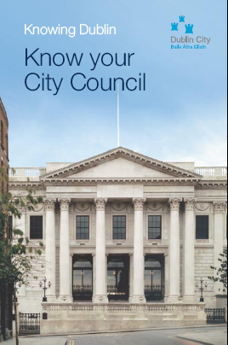
Knowing Dublin – Know Your City Council
This is a new resource very suitable for all those studying local government in CSPE. While the focus is on Dublin City Council the material has wider application, and in any case it is a welcome case study in local government. Any teacher interested in getting a copy should contact Bernadette Cogan,
Divisional Librarian, Central Library Services, ILAC Centre
Dublin 1, Tel: 01 8734333. The resource describes the following: how to register to vote, how councilors carry out their duties, how the democratic process works. it also lists the main services and responsibilities of Dublin City Council and includes a list of recommended reading and sources for further research. In conjunction with the work on this resource over sixty students undertaking the third year CSPE (Civic Social and Political Education) projects recently participated in a pilot workshop on local democracy at work in Dublin’s City Hall.
This pilot workshop, organised during Local Democracy Week, provided students from Blessington Community School and John Scottus School, Donnybrook with a first-hand experience of visiting Dublin City Council’s chamber, where decisions are made relating to Dublin City and its citizens.
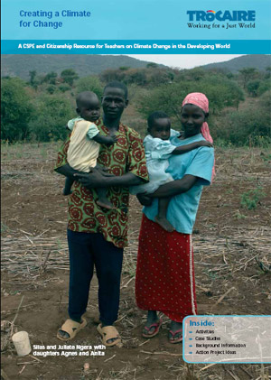
Trócaire Climate Change Resource
Trócaire's CSPE resource on Climate Change focuses on the impacts of climate change on the developing world. This resource specifically features the country of Kenya. The resource uses case studies of families with whom Trócaire works and explores how their livelihoods have been devasted by climate change. It contains various methodologies and activities that teachers can use in the classroom. The resource is available free of charge from Trócaire (01 6293333). Alternatively it can be downloaded from Trócaire's website here, http://www.trocaire.org/en/resources/secondary-school.

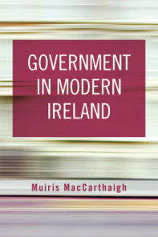
Government in Modern Ireland – A Resource for Teachers
The Institute of Public Administration has published a book that should be a useful resource for teachers of CSPE. Written by Muiris MacCarthaigh and costing €20, Government in Modern Ireland includes chapters on The Constitution of Ireland, The Office of the President, Dáil Éireann, The Government, The Civil Service, State Agencies, State Enterprises, Local Government, The Health Services, The Education System, Justice and the Courts, An Garda Síochána, The Defence Forces, Northern Ireland, and the EU.

Activate is published once per school term by the Association of CSPE Teachers—supporting citizenship education in Ireland. Articles and letters for publication should be sent to the editor, Brendan O’Regan, Arklow CBS, Co. Wicklow, 0402-39176, or emailed to info@cspeteachers.ie

